Day 2
Mandati Sharan Mahi Reddy

Set 1 – E-Commerce Catalogue and Traffic Analysis
Question 1: Binary Search Tree (BST)
Sample input:
We will use these 15 product categories:
No. | Category
1 | Electronics
2 | Clothing
3 | Books
4 | Grocery
5 | Furniture
6 | Beauty
7 | Sports
8 | Toys
9 | Automotive
10 | Cameras
11 | Home
12 | Jewellery
13 | Kitchen
14 | Lighting
15 | Mobiles

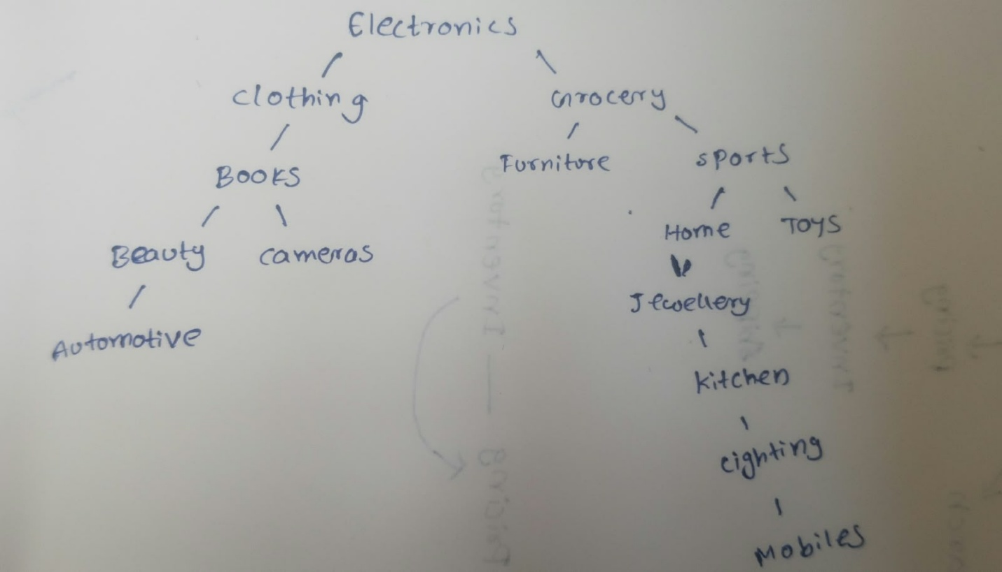

Pseudocode:
Insertion
INSERT(root, value):
If root is NULL:
Create new node
Return node
If value < root.data:
root.left = INSERT(root.left, value)
Else:
root.right = INSERT(root.right, value)
Return root

Searching
SEARCH(root, key):
If root is NULL:
Return "Not Found"
If root.data == key:
Return "Found"
If key < root.data:
SEARCH(root.left, key)
Else:
SEARCH(root.right, key)

Tree Traversals

INORDER(root):
If root is not NULL:
INORDER(root.left)
Print root.data
INORDER(root.right)

PREORDER(root):
If root is not NULL:
Print root.data
PREORDER(root.left)
PREORDER(root.right)

POSTORDER(root):
If root is not NULL:
POSTORDER(root.left)
POSTORDER(root.right)
Print root.data

Output:
Traversal | Output
Inorder | Automotive, Beauty, Books, Cameras, Clothing, Electronics, Furniture, Grocery, Home, Jewellery, Kitchen, Lighting, Mobiles, Sports, Toys
Preorder | Electronics, Clothing, Books, Beauty, Automotive, Cameras, Grocery, Furniture, Sports, Home, Jewellery, Kitchen, Lighting, Mobiles, Toys
Postorder | Automotive, Beauty, Cameras, Books, Clothing, Furniture, Mobiles, Lighting, Kitchen, Jewellery, Home, Toys, Sports, Grocery, Electronics

Complexity
Operation | Average Case | Worst Case
Insertion | O(log n) | O(n)
Searching | O(log n) | O(n)
Traversal | O(n) | O(n)
Space | O(h) | O(n)

Question 2: Hash Table with Chaining and Built-in Hash Map
Let us take,
Table Size = 5
SKU | Hash Calculation | Index
101 | 101%5 | 1
102 | 102%5 | 2
106 | 106%5 | 1
108 | 108%5 | 3
111 | 111%5 | 1

Here, 101,106,111 all get index 1. Here collision occurs.
Method 1 : Hash Table using chaining:
0 | Empty
1 | 101 -> 106 -> 111
2 | 102
3 | 108
4 | Empty

Pseudocode:
Insertion:
INSERT(key, value):
index = key % 5
Add (key, value) to table[index]

Searching:
SEARCH(key):
index = key % 5
For each item in table[index]:
If item.key == key:
Return item.value
Return "Not Found"

Method 2: Built-in Hash Map
Here, we don’t manually calculate the index or handle collisions. The dictionary manages these internally.
Pseudocode:
Insertion:
INSERT(key, value):
map[key] = value

Searching:
SEARCH(key):
If key exists in map:
Return map[key]
Else:
Return "Not Found"

Comparison of both methods
Feature | Chaining | Built-in Hash Map
Data storage | Array of lists | Key-value pairs
Hash calculation | Manually | Internally
Collision handling | Using lists | Internally managed
Search for 106 | Calculate index and traverse list | Search using key
Average lookup | O(1) | O(1)
Worst-case lookup | O(n) | O(n)

Question 3: Graph – Microservice Deployment Dependencies
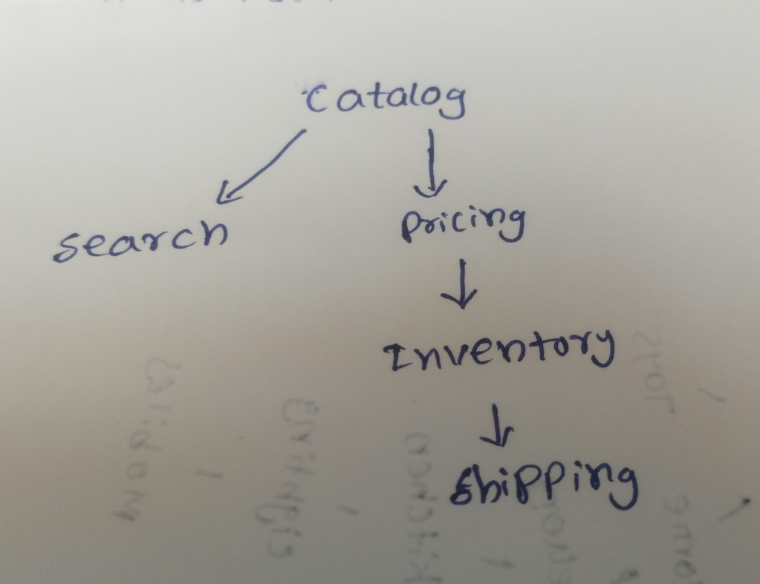
DFS approach
DFS(node):
Mark node as visited
For each neighbour:
If neighbour is not visited:
DFS(neighbour)

Add node to result
Reverse the result

Detect circular dependency
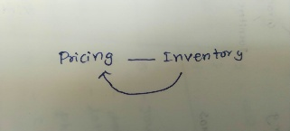

Complexity: V = Vertices , E = Edges
Operation | Time | Space
DFS | O(V + E) | O(V)
Cycle Detection | O(V + E) | O(V)

Question 4: Sliding Window – Busiest 3-Hour Period
Sample Data:
Hour | Requests
0 | 10
1 | 12
2 | 8
3 | 15
4 | 20
5 | 25
6 | 18
7 | 14
8 | 12
9 | 10
10 | 9
11 | 11
12 | 13
13 | 16
14 | 22
15 | 30
16 | 28
17 | 24
18 | 18
19 | 15
20 | 12
21 | 10
22 | 8
23 | 6

Using Sliding Window:
For First Three Hours: (0 – 2)
10 + 12 + 8 = 30
For Hours (1 – 3):
12 + 8 + 15 = 35

So if we calculate for all we will get the Busiest 3 hours for
Hours (15 – 17):
30 + 28 + 24 = 82

Pseudocode:
SLIDING_WINDOW(arr):
window_sum = arr[0] + arr[1] + arr[2]
max_sum = window_sum
best_start = 0

For i = 3 to 23:
window_sum = window_sum - arr[i-3]
window_sum = window_sum + arr[i]
If window_sum > max_sum:
max_sum = window_sum
best_start = i - 2
Print best_start
Print max_sum

Output:
Hours (15 – 17) : 82
Complexity:
Complexity | Value
Time | O(n)
Space | O(1)

Question 5: Two Pointers – Find Pairs with Target Sum
Sample Input:
[10, 20, 30, 40, 50, 60, 70, 80]
Gift Card Value:
Target = 100
Dry Run:
Left | Right | Sum | Action
10 | 80 | 90 | Move left
20 | 80 | 100 | Pair Found
30 | 70 | 100 | Pair Found
40 | 60 | 100 | Pair Found
50 | 50 | ------ | Stop

Pseudocode:
TWO_POINTERS(arr, target):
left = 0
right = length(arr) - 1
While left < right:
sum = arr[left] + arr[right]
If sum == target:
Print arr[left], arr[right]
left = left + 1
right = right - 1
Else If sum < target:
left = left + 1
Else:
right = right – 1

Output:
Pairs with sum 100:
20 + 80 = 100
30 + 70 = 100
40 + 60 = 100
Complexity:
Complexity | Value
Time | O(n)
Space | O(1)

Set 2 – Insurance Claims Processing
Question 1: Binary Search Tree (BST) – Claim IDs
No. | Claim ID
1 | 105
2 | 103
3 | 108
4 | 101
5 | 104
6 | 107
7 | 110

BST Diagram
105
/ \
103 108
/ \ / \
101 104 107 110

Output:
Traversal | Output
Inorder | 101, 103, 104, 105, 107, 108, 110
Preorder | 105, 103, 101, 104, 108, 107, 110
Postorder | 101, 104, 103, 107, 110, 108, 105

Inorder traversal gives claim IDs in sorted order because it visits the left subtree, root and right subtree.

Question 2: Hashing – Duplicate and Near-Duplicate Claims
Claim | Original Policy | Incident Date | Normalized Policy | Hash Key | Result
C1 | POL 123 | 2026-08-10 | POL123 | POL123|2026-08-10 | New Claim
C2 | pol123 | 2026-08-10 | POL123 | POL123|2026-08-10 | Duplicate of C1
C3 | POL456 | 2026-08-11 | POL456 | POL456|2026-08-11 | New Claim
C4 | POL456 | 2026-08-11 | POL456 | POL456|2026-08-11 | Duplicate of C3
C5 | POL789 | 2026-08-12 | POL789 | POL789|2026-08-12 | New Claim

Collision Handling
A collision occurs when two different hash keys generate the same index.
We use chaining to store both keys in the same bucket.
When searching, we compare the complete keys to identify the correct claim.
Complexity:
Operation | Average Case | Worst Case
Insertion | O(1) | O(n)
Duplicate Lookup | O(1) | O(n)
Space | O(n) | O(n)

Question 3: Directed Graph – Claim Approval Stages
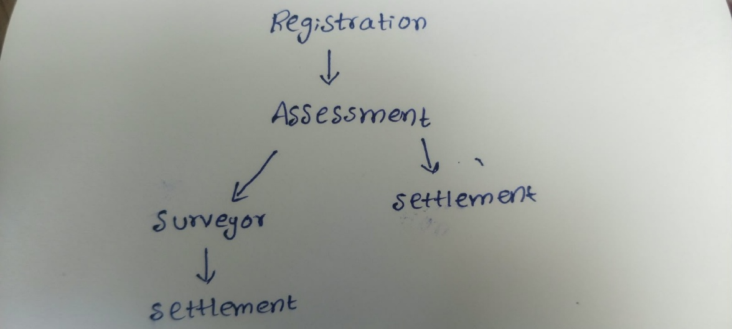
BFS – Find Shortest Path
BFS finds the shortest path because it explores the nearest nodes first.

Shortest Path Output
Registration
↓
Assessment
↓
Settlement

DFS – Detect Loops
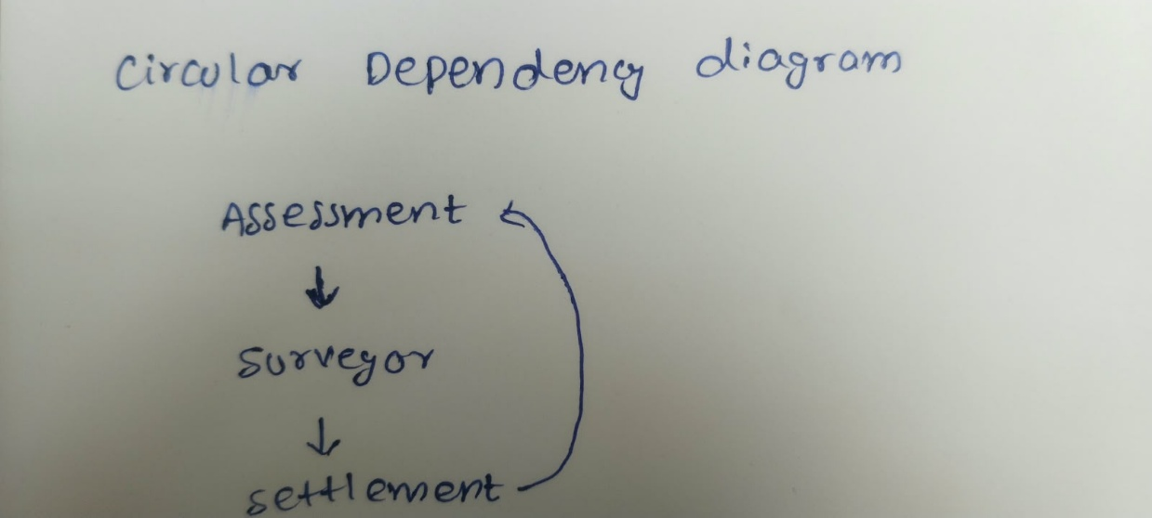
To demonstrate a loop, add an extra dependency from Settlement back to Assessment.

Question 4: Sliding Window – Longest Run of Claims
Day | Number of Claims
1 | 80
2 | 120
3 | 135
4 | 110
5 | 95
6 | 130
7 | 145
8 | 150
9 | 160
10 | 90

Dry Run
Days | Claims | Result
1 | 80 | Not above 100
2–4 | 120, 135, 110 | 3 consecutive days
5 | 95 | Reset count
6–9 | 130, 145, 150, 160 | 4 consecutive days
10 | 90 | Reset count

Output:
Days 6 – 9 have the longest consecutive run of claims exceeding 100.
Pseudocode
LONGEST_RUN(arr):
current = 0
longest = 0
For i = 0 to length(arr)-1:
If arr[i] > 100:
current = current + 1
If current > longest:
longest = current
Else:
current = 0
Print longest

Complexity
Complexity | Value
Time | O(n)
Space | O(1)

Question 5: Two Pointers – Merge Two Sorted Claim Lists
Regional Office 1
[101, 104, 108, 115]
Regional Office 2
[102, 104, 110, 118]

Dry Run
Pointer A | Pointer B | Selected Value
101 | 102 | 101
104 | 102 | 102
104 | 104 | 104 (A)
108 | 104 | 104 (B)
108 | 110 | 108
115 | 110 | 110
115 | 118 | 115
End | 118 | 118

Output:
[101, 102, 104, 104, 108, 110, 115, 118]

Pseudocode:
MERGE(A, B):
i = 0
j = 0
result = empty list
While i < length(A) AND j < length(B):
If A[i] < B[j]:
Add A[i] to result
i = i + 1
Else:
Add B[j] to result
j = j + 1
Add remaining elements of A
Add remaining elements of B
Print result

Set 3 – Logistics Network and Delivery Windows
Question 1: Binary Search Tree (BST) – Zip Codes
Sample Data:
No. | Zip Code
1 | 500
2 | 300
3 | 700
4 | 200
5 | 400
6 | 600
7 | 800

BST Diagram
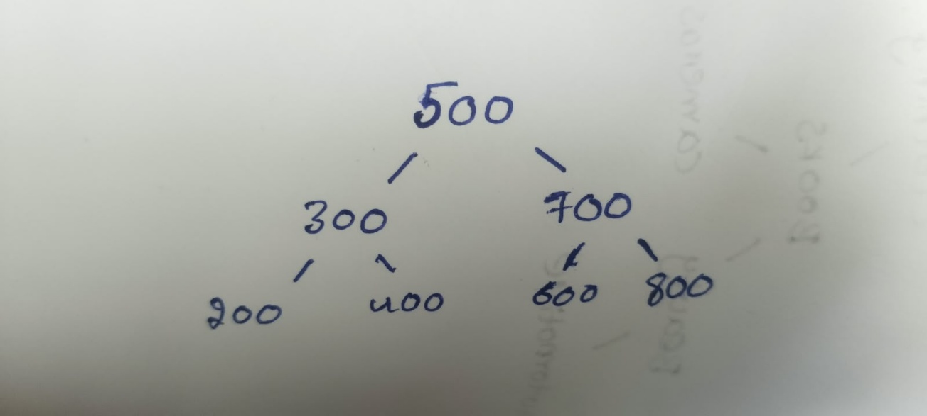
Pseudocode:
Finding Height
HEIGHT(root):
If root is NULL:
Return 0
left = HEIGHT(root.left)
right = HEIGHT(root.right)
Return 1 + maximum(left, right)

Searching
SEARCH(root, key):
If root is NULL:
Return "Not Found"

If root.data == key:
Return "Found"
If key < root.data:
Return SEARCH(root.left, key)
Else:
Return SEARCH(root.right, key)

Output
Search 600 → Found
Height of the tree → 3 levels

Effect of Sorted Input
Suppose if we insert in Sorted Order,
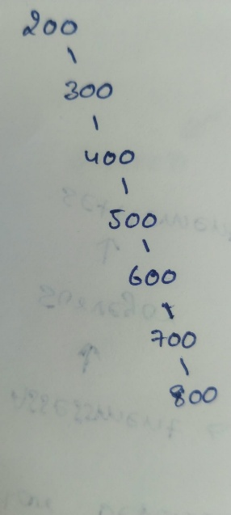

Insertion Order | Height
Unsorted | 3
Sorted | 7

Sorted input creates a one-sided tree, increasing its height and making searching slower.

Question 2: Hashing – Duplicate Parcel Tracking
Parcel ID | Hub | Hash Key | Result
P101 | H1 | P101-H1 | First Scan
P102 | H2 | P102-H2 | First Scan
P101 | H1 | P101-H1 | Duplicate
P103 | H1 | P103-H1 | First Scan
P102 | H2 | P102-H2 | Duplicate
P104 | H3 | P104-H3 | First Scan
Pseudocode
CREATE empty hash map
CHECK_SCAN(parcel, hub):
key = parcel + hub
If key exists in map:
Print "Duplicate Scan"
Else:
map[key] = 1
Print "First Scan"

Collision Handling
Index 2 → P101-H1 → P102-H2
we use chaining to store them in the same bucket.
We compare the complete keys to identify the correct parcel.
Output:
P101-H1 → Duplicate Scan
P102-H2 → Duplicate Scan
Complexity
Operation | Average Case | Worst Case
Insertion | O(1) | O(n)
Searching | O(1) | O(n)
Space | O(n) | O(n)

Question 3: Graph – Logistics Network and Shortest Route
Sample Graph
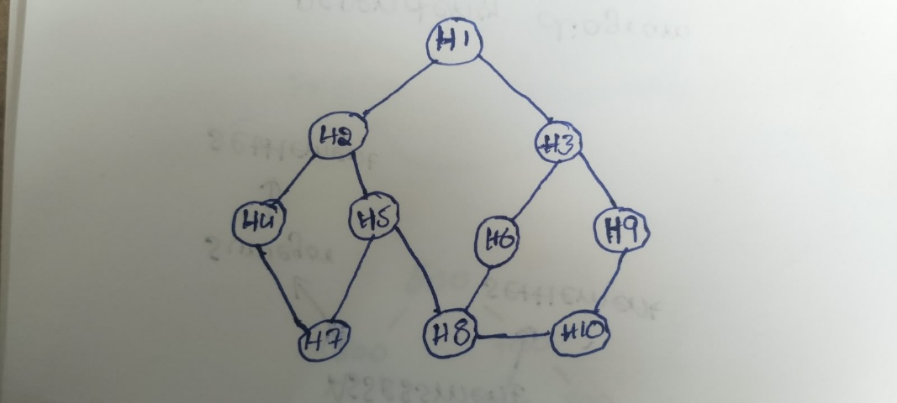

Adjacency List
Hub | Connected Hubs
H1 | H2, H3
H2 | H1, H4, H5
H3 | H1, H6, H9
H4 | H2, H7
H5 | H2, H7, H8
H6 | H3, H8
H7 | H4, H5
H8 | H5, H6, H10
H9 | H3, H10
H10 | H8, H9

BFS – Find the Shortest Route
Pseudocode
BFS(start, target):
Create empty queue
Add start to queue
Mark start as visited
While queue is not empty:
Remove front hub
If hub == target:
Print path
Stop
For each neighbour:
If neighbour is not visited:
Mark neighbour as visited
Add neighbour to queue
Shortest route:
H1 → H3 → H9 → H10

DFS – Find Reachable Hubs
DFS(hub):
Mark hub as visited
Print hub
For each neighbour:
If neighbour is not visited:
DFS(neighbour)
Output
H1 → H2 → H4 → H7 → H5 → H8 → H6 → H3 → H9 → H10
Complexity
Operation | Time | Space
BFS | O(V + E) | O(V)
DFS | O(V + E) | O(V)

V = Number of Vertices, E = Number of Edges
Question 4: Sliding Window – Highest 4-Hour Average
Hour | Parcel Count
1 | 10
2 | 12
3 | 8
4 | 15
5 | 20
6 | 25
7 | 18
8 | 14
9 | 12
10 | 10
11 | 9
12 | 11

Dry Run
Hours | Parcel Counts | Average
1–4 | 10, 12, 8, 15 | 11.25
2–5 | 12, 8, 15, 20 | 13.75
3–6 | 8, 15, 20, 25 | 17
4–7 | 15, 20, 25, 18 | 19.5
5–8 | 20, 25, 18, 14 | 19.25

The highest average is 19.5
Answer: Hours 4–7 have the highest average parcel count.
Pseudocode:
SLIDING_WINDOW(arr):
sum = arr[0] + arr[1] + arr[2] + arr[3]
max_sum = sum
best_start = 0
For i = 4 to length(arr)-1:
sum = sum - arr[i-4]
sum = sum + arr[i]
If sum > max_sum:
max_sum = sum
best_start = i - 3
average = max_sum / 4
Print best_start
Print average
Complexity:
Complexity | Value
Time | O(n)
Space | O(1)

Question 5: Two Pointers – Check Palindrome Route
Sample:
H1 - H2 - H3 - H2 - H1
Dry Run
Left | Right | Comparison
H1 | H1 | Match
H2 | H2 | Match
H3 | H3 | Match

All Hub Codes Match. Therefore, it is a Palindrome
Pseudocode:
CHECK_PALINDROME(route):
Convert route to uppercase
Split route using separators
left = 0
right = length(route) - 1
While left < right:
If route[left] != route[right]:
Return "Not Palindrome"
left = left + 1
right = right - 1
Return "Palindrome"
Complexity:
Complexity | Value
Time | O(n)
Space | O(n)

